News
FOR IMMEDIATE RELEASE
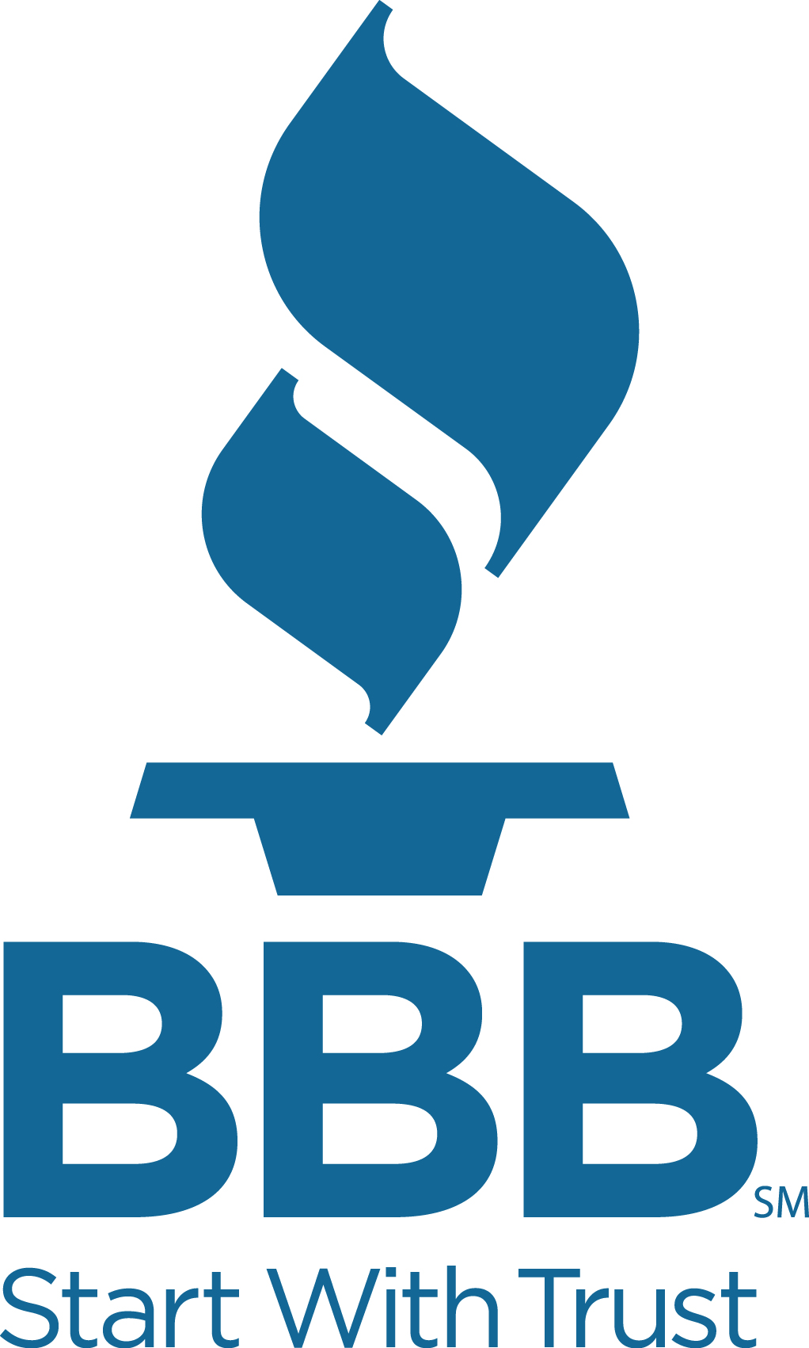

BBB – Rockford Regional Office
Rockford, IL 61101
815.963.2226
815.323.8419 (cell)
815.963.0329 (fax)
www.bbb.org

Contact: Dennis Horton
BBB - Rockford Regional Office
dhorton@chicago.bbb.org

Don’t Fall for “Spring Repair and Maintenance Scams

Rockford, IL – March 28th, 2017 – As temperatures and Spring flowers start popping up – so will the seasonal rush of home improvement scammers. The BBB “Scam Tracker Top Scams Risk Index Report” just released by the BBB Institute of Marketplace Trust, shows home improvement scams at the top of the risky scam list for the dangers they pose to consumers.
The BBB Risk Index measures risk to consumers along three dimensions:
- Exposure (how likely are you to be exposed to the con?)
- Susceptibility (if you are exposed, how likely are you to lose money?) and
- Monetary loss (if you lose money, how much is it likely to be?).
Exposure X Susceptibility X Monetary Loss = Risk Index
Based on the BBB Risk Index, the riskiest top scams overall are:
- Home improvement scams (bbb.org/homescam)
- Fake checks and money orders (bbb.org/fakecheckscam)

Homeowners throughout Chicago and northern Illinois are spiffing up their homes and yards with a variety of improvement projects. But, the Better Business Bureau warns there are crooks and con-artists looking to clean up by taking advantage of those same homeowners.
Every year hundreds of complaints roll in regarding Air Conditioning and Heating, and Landscape Contractors.
"We are certain to receive a steady stream of home improvement complaints each year but the number of consumers who become victims can be reduced if they take care in finding the right business to perform the work they want done," says Dennis Horton, director of the Rockford Regional Office of the Better Business Bureau. "Always be sure you know who you are dealing with".
"The BBB has information available online that can help guide consumers in their search for businesses to help them with their spring projects," states Horton.

Additionally, he notes "We also have available to consumers our online "Request A Quote" program where they can ask to be contacted by BBB Accredited Business.

Tips to follow that can help prevent getting ripped-off this spring:
- Ask for references. Seek at least three references and be sure follow-up by contacting them.
- Hire a professional. Research companies for free at ask.bbb.org
- Be wary of door-to-door solicitations. Each year, countless homeowners have companies knock on their door and offer to provide their services at a discount. In too many cases, the work performed is shoddy or only partially completed - and the company fails to return, as promised.
- Get everything in writing. A contract should clearly state the services you will receive, as well as when the job is expected to be completed, payment terms and conditions, contact information for the company - phone number and address - as well as any refund or cancellation policy.
- Verify insurance coverage. Confirm that the company has insurance that covers worker's compensation, property damage and personal liability in case of accidents.

Horton cautions, "Remember, you're the customer; it's your home. Don't feel pressured to choose a business just because someone is standing on your doorstep. You also want to avoid paying in cash and should never write a check to a company employee."
###

Search our databases anytime at no cost to help you find trustworthy businesses and other important consumer information. Visit http://ask.bbb.org. Follow us on Facebook, Twitter or add us on Instagram

ABOUT BBB: For more than 100 years, Better Business Bureau has been helping people find businesses, brands and charities they can trust. Consumers and businesses can search business reviews and ratings on more than 5.3 million businesses and Charity Reports on 11,000 charities, all available for free at bbb.org. The Council of Better Business Bureaus is the umbrella organization for the local, independent BBBs in the United States, Canada and Mexico, as well as home to its national programs on dispute resolution, advertising review, and industry self-regulation.

